horizontal line

**Delhi Technological University**

Department of Applied Physics

IVth Semester

**MICROPROCESSORS & INTERFACING**

**MPI EP - 206**

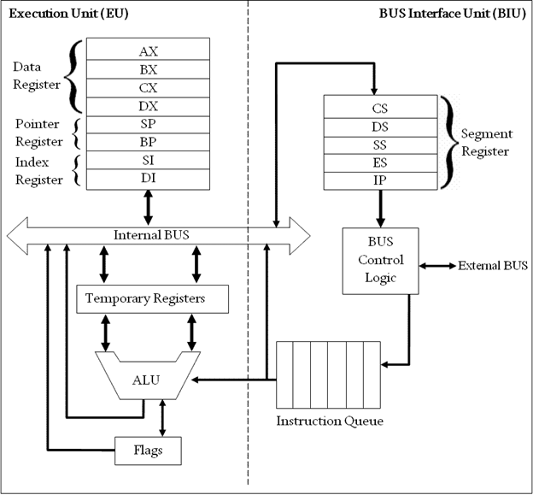

# **Submitted by :**

**ADITYA SINGH, 2K19/EP/005**

**Submitted to:**

**Dr. Rishu Chaujar**

# **Experiment 10**

**Find the Largest Number in a set of 16, 8-bit Numbers.**

**THEORY**

1. The number of elements is stored in the CX register.
2. It is assumed that the first element is the largest number and this element is stored in the AX register.
3. Now the program iterates through the remaining elements and whenever it encounters a larger element than before, the particular element is stored in the AX register.
4. l1: (loop)
5. Store the current element in the BX register and compare with the AX register. If the element in the BX register is greater than in the AX register then go to step 7. Else copy the contents of BX to AX register.
6. Repeat step 5 until CX=0
7. Decrement value in CX register and go to step 4 until CX=0.
8. The AX register will have the largest element at the end of the program.

**CODE**

**org 100h**

**mov si,2000h**

**mov cx,[si]**

**dec cx**

**mov si,2010h**

**mov ah,[si]**

**mov al,[si+1]**

**l1:**

**add si,10h**

**mov bh,[si]**

**mov bl,[si+1]**

**cmp bx,ax**

**jc skip**

**mov ax,bx**

**loop l1**

**hlt**

**skip:**

**dec cx**

**cmp cx,0**

**jnz l1**

**hlt**

**OUTPUT**

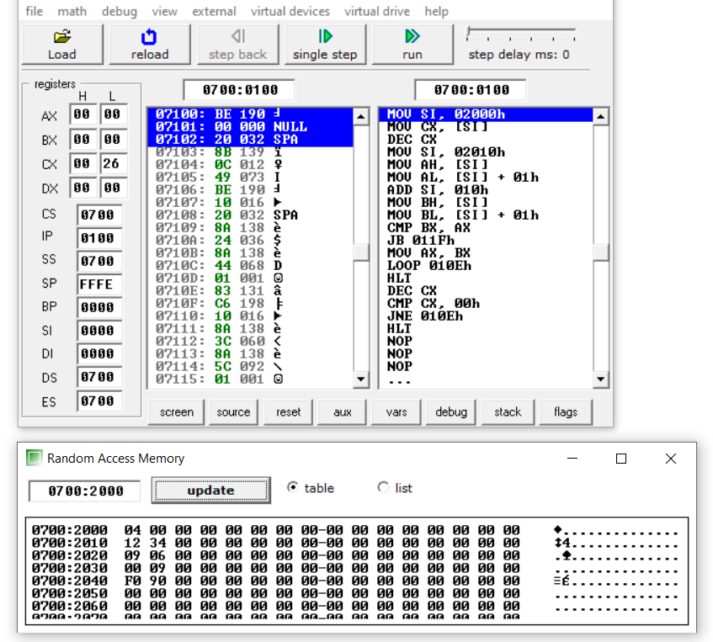

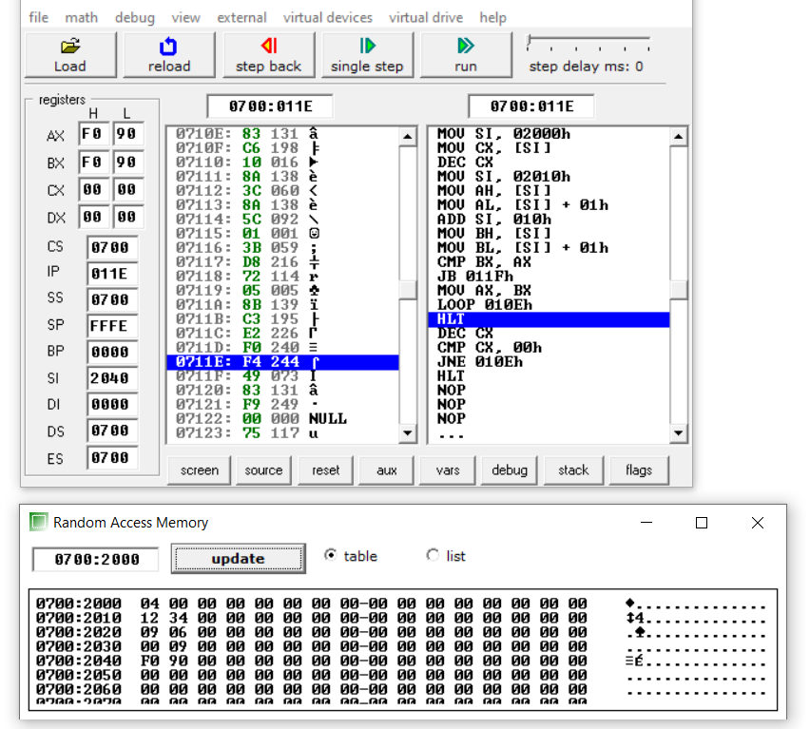

**END**